

ISOM4007(002) Graduation Project Proposal
Digitizing Cross-boundary Private Car Insurance: An AI-powered Self-service Insurance Platform

BC103444 QU YUMING Macro
BC102362 HO CHANHOU Alvin
BC102628 WANG TSZ CHING Phoebe
BC101603 ZHAN ZIYUE Moon
BC105089 CHEN RUOHAN Dorothy
BC104812 ZHANG XIZHE Terrence

CONTENTS
Introduction 3
Problems of the Current Application / Industry 3
Requirements Definition 4
- Functional Requirements 4
- Non-functional Requirements 6
Scope & Benefits of the Proposed System 8
- Scope of the new system 8
- Benefits and achievements of the new system 8
- Schedule of the development of the new system 9
Conclusion 10

Introduction
In order to promote exchange and development within the Great Bay Area, the Macau government has been continuously issuing regular quotas for Macau private vehicles to travel around Macau, Hong Kong and Mainland China. Since 2021, a cumulative total of over 20,000 quotas has been allocated, and this number continues to grow. Given that the Hong Kong-Zhuhai-Macau Bridge is jointly managed by Hong Kong, Macau and Mainland China, all Macau private vehicles holding these quotas (hereafter referred to as "cross-boundary car") are required to purchase additional Mainland Compulsory Traffic Insurance and Hong Kong Car Insurance (collectively referred to as "cross-boundary vehicle insurance") in order to access the bridge.
Beyond just focusing on cross-boundary auto insurance, it's important to consider the broader technological and social context in which it happens. Increasingly, businesses are facing significant technological development by integrating trendy applications such as large language models and AI models into their systems. These innovations are not only improving manual efficiency but also reshaping various industries by streamlining processes and enhancing decision-making capabilities.
This final year project proposal will explore the regulatory framework, market implications, and operational challenges associated with the cross-boundary vehicle insurance business, aiming to provide business insights and sample functions for further development.

Problems of the Current Application / Industry
In the current cross-boundary car insurance process, several inefficiencies and challenges hinder meeting customer expectations and optimizing operations. Firstly, the process heavily relies on manual operations, where staff manage every stage from customer inquiry to policy issuance. This results in extended processing times, with some clients waiting up to 14 working days to complete transactions, leading to complaints about service inefficiencies.
Secondly, during peak periods, the system struggles with high volumes of inquiries and insurance requests, making scalability an issue. Staff face heavy workloads, causing response delays, data processing errors, and decreased customer satisfaction.
Using Excel spreadsheets for data management also introduces errors such as incorrect or missing entries, complicating accurate record-keeping and insightful data analysis. This manual approach limits the company's ability to assess business performance or identify areas for improvement effectively.
Moreover, diversified customer needs have also posed challenges to the insurance industry. As awareness of insurance increases, customers are no longer satisfied with the specific products available but are looking for personalized insurance solutions tailored to their own possible risks. The lack of real-time guidance and automated workflow makes it difficult for customers in need to receive timely guidance, in addition to ambiguity and trust issues in communication.
These issues underscore the pressing need for an AI-driven platform to streamline operations, enhance productivity, and elevate the customer experience.

Requirements Definition

- Functional Requirements
The functional requirements of the platform revolve around user roles and their respective permissions. As the highest authority role in the system, administrators can perform operations such as user management, insurance application management, policy management, and data statistics. Specific tasks include adding or deleting user accounts, modifying user profiles, adjusting user permissions, reviewing insurance applications, viewing and managing all policies, and accessing the data statistics dashboard. Managers have more limited permissions, primarily including modifying and reviewing insurance applications, viewing and managing policies, and accessing the data statistics dashboard. Users (guests) can utilize the platform's insurance services and policy management services, enabling them to select different insurance products or combinations for their vehicles, submit applications and make purchases online, view and manage policies under their name, and access AI-powered customer service.

The AI customer service is a key feature of the platform, capable of answering customer inquiries based on pre-configured question-answer pairs in the platform's knowledge base. However, if sensitive issues or questions beyond the AI's capability arise, the system will automatically create a support ticket and assign it to a human customer service staff for resolution, ensuring that customer issues are properly addressed. Additionally, users can browse and sign documents on the platform and make online payments, further enhancing the user experience.

For special user groups such as insurance agents and brokers, the platform provides additional functionalities. In addition to all the features available to regular users, they can view and manage all policies under their clients' names and apply specific discount rates (0%, 5%, or 10%) for their clients. Furthermore, insurance agents and brokers are allowed to maintain accounts and utilize monthly settlement features, facilitating their financial management. It is worth noting that insurance agents and brokers have dedicated entrance to the platform, and their accounts are created and issued by platform administrators, preventing self-registration to ensure platform security and controllability.

The backend data statistics functionality is highly robust, allowing administrators and managers to freely set time ranges and generate statistical charts for the selected periods. Product types can be filtered, enabling users to view data for specific products as needed. During the insurance application process, each step requires user confirmation, and the relevant information is sent to the backend in real time for review by managers or administrators. Managers and administrators can approve, reject, or manually modify the content provided by clients, adjust documentation, and push the revised version back to the client for final confirmation. Additionally, the platform features OCR (Optical Character Recognition) functionality during the application process, automatically extracting information from identification documents uploaded by clients to improve data entry accuracy and efficiency.

The platform's functional architecture is divided into frontend and backend components. The frontend primarily serves users, supporting registration, profile completion, purchasing cross-boundary vehicle insurance products, and providing AI customer service. The backend serves administrators and managers, encompassing user management, insurance application management, policy management, and data statistics functionalities to ensure efficient platform operation and management. Through the collaboration of the frontend and backend, the platform delivers a comprehensive and seamless insurance service experience for users while equipping administrators and managers with powerful tools to support ongoing business development.

- Non-functional Requirements
The platform must meet stringent non-functional requirements to ensure optimal performance, security, and user satisfaction. It should also comply with the ISO/IEC 25010 quality standard as far as possible.

In terms of functional suitability, the platform should ensure that customers are only able to take out policies in accordance with the set enrolment process and that key information at each step is double-checked to confirm that the customer's enrolment information is accurate, thereby ensuring that the policies issued meet the compliance requirements of the financial regulatory authorities.

In terms of functional accuracy, the exchange rate should be stored in the database as an integer value combined with a scaling factor (e.g., 1000 for 3 decimal places). This approach ensures that all calculations are performed using integers, avoiding precision issues that may arise from floating-point arithmetic. Data involving money, such as premiums, should also be stored in units of 'cents', thereby avoiding quotation discrepancies and ensuring that the price of the product is consistent with the price actually displayed to the user.

Information security is a core requirement of the platform. All user data (including personal information and payment details) must be encrypted during transmission, and Static data, such as passwords and identification numbers, must be stored using double hashing (e.g., SHA-256) to prevent unauthorized access in the event of a data breach. Platforms are required to implement role-based access control (RBAC) to prevent unauthorized access and conduct regular security audits and penetration tests to identify and address vulnerabilities. Users should leave traces when accepting quotations and signing insurance application forms to enhance authenticity and non-repudiation. Additionally, the AI-based customer service system must be isolated from the core database, accessing data only with strict permission controls to prevent data leaks.
Compatibility requires the platform to be able to integrate seamlessly with other business systems. The OCR function should support common document formats and identification documents from major jurisdictions.
The platform needs to be highly scalable. The database and server infrastructure should support seamless expansion, allowing new products to be added or existing products to be deleted without extensive modifications to the main body of the platform, in order to cater for future growth business needs.

In terms of ease of use, the user interface should be designed to be intuitive and compliant with WCAG 2.1 standards, ensuring that clear guidance and tooltips are provided for all major functions to minimize the need for external support. The user interface of the platform should have progress indicators and prompts for estimated completion times to minimize user anxiety. The platform should support major web browsers and provide responsive design for desktop, tablet, and mobile devices. For information with a certain format, such as email address, phone number, Chinese name, and English name, provide examples for users to refer to and validate during input to ensure the accuracy of user input to enhance user error proofing.

In terms of maintainability, the main functions are modularly constructed and accompanied by relevant documentation to ensure that the product can be effectively and efficiently modified by the expected maintenance staff.

In terms of performance efficiency, the system should support at least 100 concurrent users, with an average operational response time of no more than 2 seconds under normal load conditions and a statistical data report generation time of no more than 20 seconds, with a time horizon of up to one year.

In terms of reliability, the platform has a target uptime of 99.9% (excluding planned maintenance), and planned maintenance shall not exceed 8 hours per month with at least 48 hours advance notice to users. In addition, the platform is required to implement a regular backup mechanism, store critical data in different geographic locations, and establish clear disaster recovery procedures to ensure rapid service recovery in the event of a catastrophic failure.

With the above non-functional requirements, the platform ensures high performance, high security, user-friendliness, reliability, and scalability while complying with the quality standards of ISO/IEC 25010, and at the same time enables this platform to flexibly cope with the future growth and adjustment of the business.

Scope & Benefits of the Proposed System

- Scope of the new system
The scope of our new system is mainly focused on all the upstream and downstream industry workers and customers who use our platform. For cross-boundary tourists, AI consulting can provide them with personalized insurance plans and analyze the terms of insurance contracts. As for global-selling companies, AI consulting can conduct risk assessment and claims process analysis for them to find the most suitable insurance products. We also have other industries that need this function, such as car rental companies and international logistics companies.

- Benefits and achievements of the new system
- The AI function can quickly respond to customer questions and inquiries, reducing the waiting time of users; AI's knowledge base is more comprehensive and powerful than the human brain, and it can provide users with better consultation.
- AI functions can reduce the workload and manpower of manual customer service, thereby saving the operating costs of the system, improving the efficiency of consulting, and providing users with 24-hour advisory services.
- In the face of consulting that requires data analysis, AI-built-in automated analysis is faster than human analysis.
In short, driven by AI, our system enhances the user experience, increases conversion rate, and saves the human operation cost of the platform.
- To give different positions of employees with different system management rights can be better coordinated between the work of various departments and improve the security and reliability of the system.
- The introduction of the background statistics function improves the efficiency and accuracy of data entry and document filling, which can bring better user experience.
- The system will comply with international standards in functionality, compatibility, and security, which enhances the credibility and competitiveness of the system.
- The main functions of the system are modularized, providing high convenience for future system expansion and maintenance. It also improves the compatibility and flexibility of the system.
- The system provides users with clear usage guidelines and tool tips, which reduces learning costs and further enhances the user experience.

- Schedule of the development of the new system
- Build the underlying web code and initialize the platform.
- Integrate cross-boundary motor insurance business data, customer data, market data, etc., perform data pre-processing (clean and standardised data) to provide Demo data for back-end analytical functions; build up knowledge base to train LLM model.
- Clarify the function requirements of the system and set the overall structure of the system web page. Design the simple user interface(UI).
- Test the system function and optimize it.
- Report and present.

Critical Timeline:
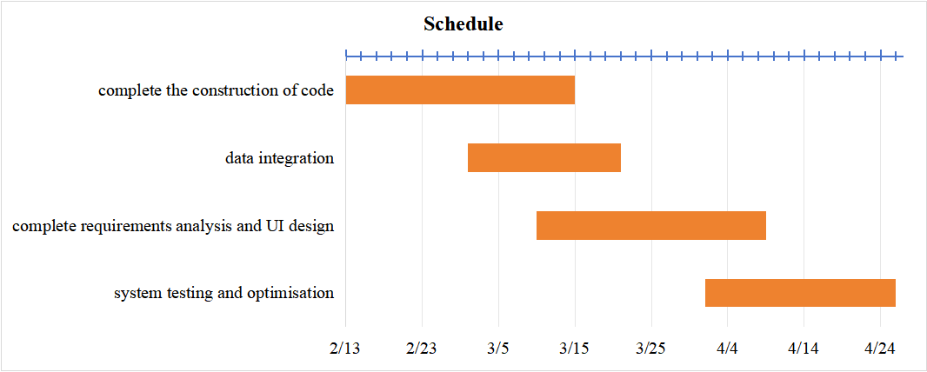

Conclusion
By introducing automated processing systems and artificial intelligence customer service, we have solved the long-standing pain points of inefficiency and poor customer experience in Macau's insurance industry. This innovation not only significantly improves service efficiency, but also provides timely support to customers, which greatly enhances customer satisfaction. We also hope to promote the innovation and development of the entire insurance industry in Macau and contribute to the development of the Greater Bay Area. In the future, we hope that AI will not only be used in the customer service area of the system, but also in areas such as marketing quotes. By recommending insurance products based on the personal information of different customers and providing an attractive price through an intelligent quotation system while ensuring objective profitability, we can not only effectively improve customer loyalty but also greatly increase the company's profitability and market share. Through this graduation project, we hope to explore the possibilities of the integration of artificial intelligence and data analytics and provide intelligent solutions to practical business problems.

